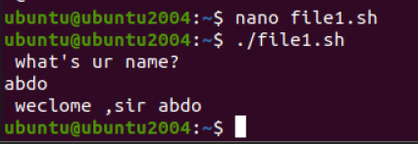
1. Create a script that asks for user name then send a greeting to him. 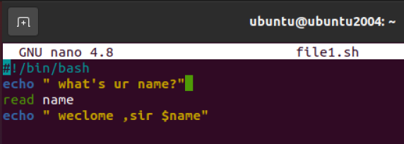
or
Read –p “enter name” logname

2. Create a script called s1 that calls another script s2 where:
a. In s1 there is a variable called x, it's value 5
b. Try to print the value of x in s2 by two different ways.
A , b way1 with export
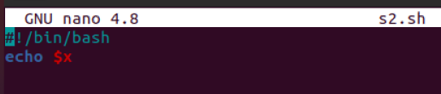
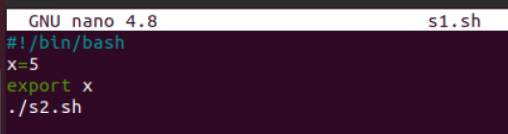
B way2 passing arg

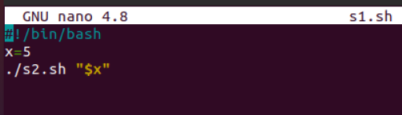
3. Create a script called mycp where:
a. It copies a file to another directory
b. It copies multiple files to a directory.
Ans: cp $*
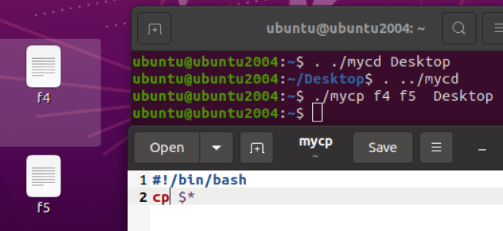
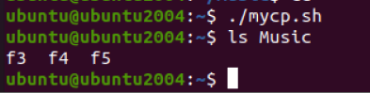
4. Create a script called mycd where: use source when call it
a. It changed directory to the user home directory, if it is called without arguments.
b. Otherwise, it change directory to the given directory.
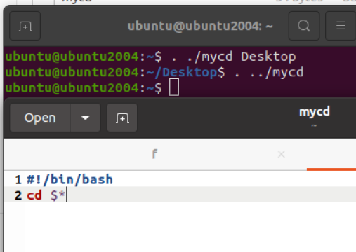
5. Create a script called myls where:
a. It lists the current directory, if it is called without arguments.
b. Otherwise, it lists the given directory.
Ans : ls $*
Or
ans
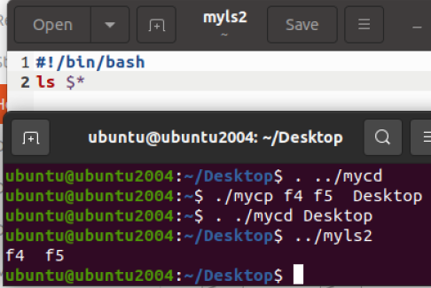
6. Enhance the above script to support the following options individually:
a. –l: list in long format
b. –a: list all entries including the hiding files.
c. –d: if an argument is a directory, list only its name
d. –i: print inode number
e. –R: recursively list subdirectories
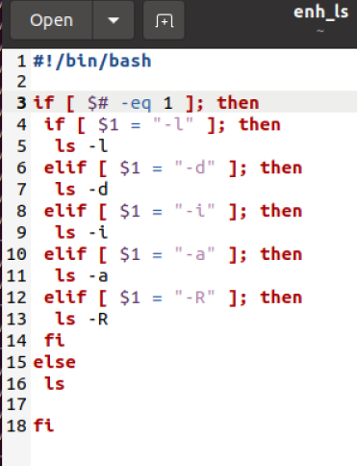
7. Create a script called mytest where:
a. It check the type of the given argument (file/directory)
b. It check the permissions of the given argument (read/write/execute)
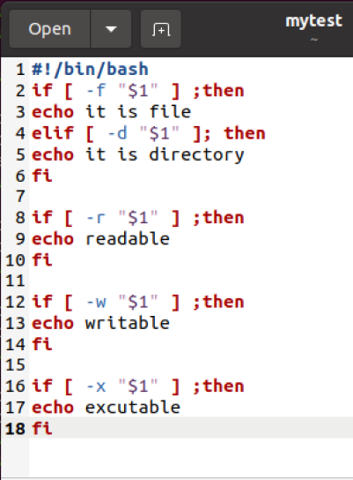
8. Create a script called myinfo where:
a. It asks the user about his/her logname.
b. It print full info about files and directories in his/her home directory Check by id command exists or not (id ahmed)
if [ id $logname ] ; then
home=”grep –w ^$logname /etc/passwd | cut –d: -f6 ”
ls –l $home

c. Copy his/her files and directories as much as you can in /tmp directory.
cp –r $home /tmp

d. Gets his current processes status.
Ps –u $logname
fi
Ans: take the path of home
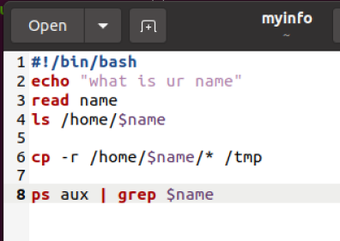

Bonus: enhance the above script to support the following Synopsis:
myls -option1 –option2
myls –option2 –option1
myls –option1option2
myls –option2option1
